Nama : Marchten Verisa AS

Nim : 202321420004

Prodi : Teknik Informatika

package uaskomputasinumerik;

public class Uaskomputasinumerik2 {

public static double fungsiF(double x) {

return x \* x + 1;

}

public static double fungsiG(double x) {

return 2 \* x;

}

public static double hitungLuas(double a, double b, int n, Fungsi f, Fungsi g) {

double h = (b - a) / n;

double luas = 0.0;

for (int i = 0; i < n; i++) {

double x1 = a + i \* h;

double x2 = a + (i + 1) \* h;

luas += 0.5 \* h \* (f.hitung(x1) + f.hitung(x2) - g.hitung(x1) - g.hitung(x2));

}

return luas;

}

public static void main(String[] args) {

double a = 0;

double b = 2;

int n = 1000; // Jumlah subinterval

Fungsi fungsiF = x -> x \* x + 1;

Fungsi fungsiG = x -> 2 \* x;

double luas = hitungLuas(a, b, n, fungsiF, fungsiG);

System.out.println("Luas daerah: " + luas);

}

interface Fungsi {

double hitung(double x);

}

}

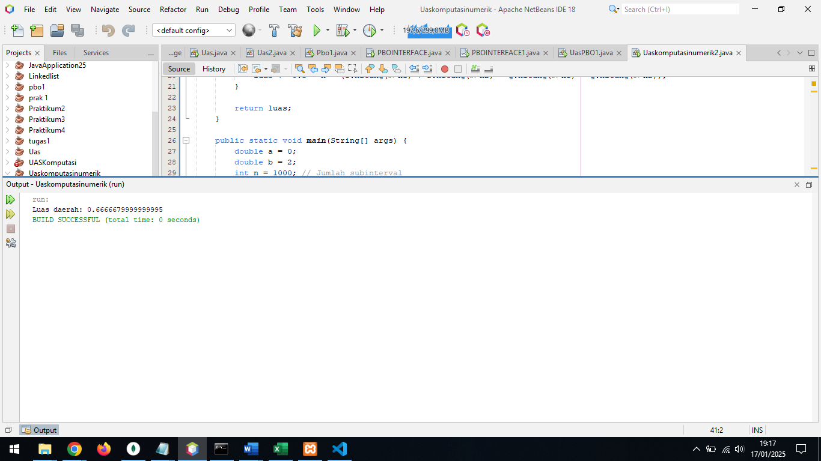

Luas daerah adalah: 0.6666679999999995